Random Forest ML Model for Breast Cancer Images

Classification
- CNN features were extracted from all histopathology images to represent important visual patterns.
- A Random Forest classifier was used due to its good performance with high-dimensional features and minimal tuning requirements.
- The extracted features and labels were used to train the model.
- The dataset was split using a patient-level split to avoid data leakage, ensuring that images from the same patient were not shared between training and testing sets.
- An 80/20 stratified split was applied to maintain the class distribution.
- Class imbalance was handled by applying class weighting during training.
- The quality of the extracted features was confirmed by the high ROC-AUC score obtained during evaluation.

Metrices
Using the default decision threshold (0.5), the model achieved:
- Accuracy: 85%
- Precision (cancer): 0.77
- Recall (cancer): 0.70
- F1-score (cancer): 0.73
- ROC-AUC: 0.91

These metrics were chosen to provide a balanced evaluation, with special focus on recall and ROC-AUC due to their importance in medical diagnosis tasks.

Threshold Optimization Results
In medical applications, recall (sensitivity) is more important than precision because missing malignant cases can have serious consequences.
To improve recall, different probability thresholds were evaluated:
(0.5, 0.4, 0.3, and 0.2)

Threshold | Precision | Recall | F1-score
0.5 | 0.77 | 0.70 | 0.73
0.4 | 0.72 | 0.78 | 0.75
0.3 | 0.65 | 0.85 | 0.74
0.2 | 0.58 | 0.91 | 0.71

- Threshold 0.4 provides the best balance between precision and recall.
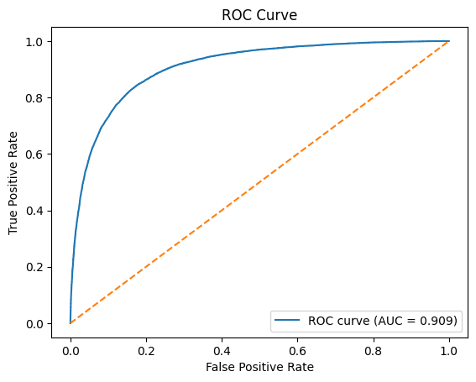
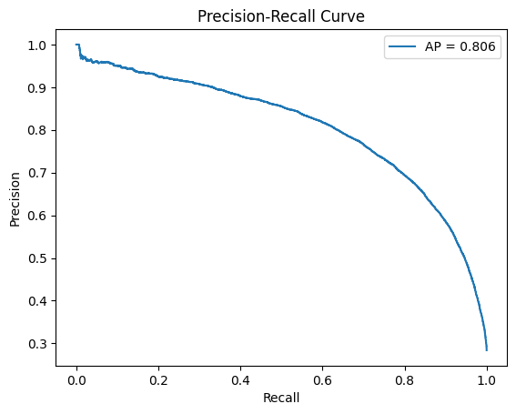
- Threshold 0.3 maximizes recall, making it suitable when sensitivity is the top priority.

